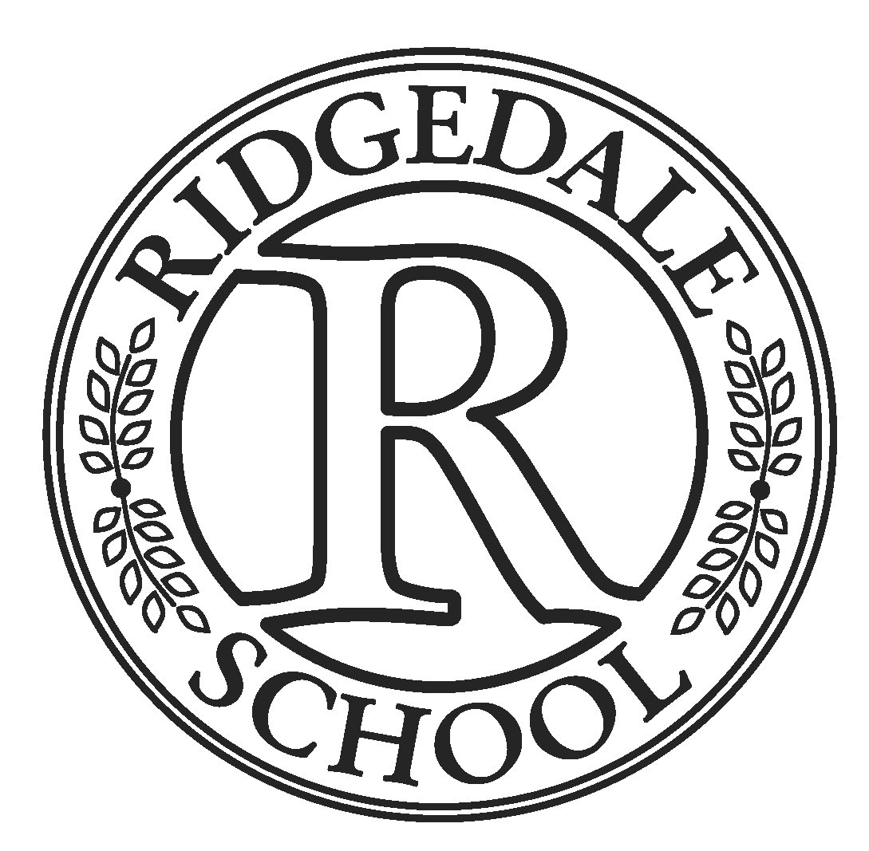

**Ridgedale School**

**Parent Compact 2020 - 2021**

**The following compact outlines how Ridgedale School, our families and our students will increase our shared responsibility for improving student behavior and academic achievement. Ridgedale School, our students, and families will be engaging in activities, services and programs funded by Title I, Part A of the Elementary and Secondary Education Act (ESEA) and agree to the following commitments of this compact:**

***Ridgedale School Responsibilities***

1. Provide high-quality behavior and instructional programs in a supportive and effective

learning environment that enables our students to meet the state’s student academic achievement standards as follows:

* Provide a full-time instructional coach to support Tier 1 instruction and monitoring fidelity of intervention
* Implement research based instructional programs for students receiving Tier 2 and Tier 3 instruction.
* Implement Restorative Practices to foster a positive healthy school climate and help students learn from their mistakes.
* Provide a full time Restorative Interventionist to support students and teachers in implementing Restorative Practices.
* Provide training for all staff in ACEs (Adverse Children Experiences and Trauma-Informed practices including strategies on how to support those students in our school and classrooms.

2. Hold parent-teacher conferences and other parent meetings (Collaborative Team Meetings and IEP meetings) during which this compact will be discussed as it relates to the individual child’s achievement. Due to Covid19, conferences will be held virtually. Specifically, those conferences will be held:

* Fall Open House and Parent Conferences
* Individual Transition Planning in the Spring
* Spring Open House and Parent Conferences
* Collaborative Team Planning Meetings
* IEP Meetings

3. Provide parents with frequent reports on their children’s progress.

Specifically, the school will provide reports as follows:

* Weekly Positive Parent Calls
* School website
* Parent Portal
* Daily Home-School Communication Note
* Ridgedale Newsletter

4. Provide parents reasonable access to staff. Specifically, staff will be available for consultation with parents as follows:

* Email
* Parent/teacher conferences at parent or school request
* School Support Teams at parent or school request
* IEP meetings
* Direct calls to the classroom

***Parent Responsibilities***

Parents can support their child’s learning in the following ways:

* Monitoring attendance.
* Reading the Home-Communication Note every day.
* Help my child practice the behavior skills he/she is learning at school.
* Staying informed about my child’s education and communicating with the school by promptly reading all notices from the school or the school district either received by my child or by mail
* Serving, if possible, on any school or district committees/advisory groups that will benefit my child’s education.

***Student Responsibilities***

Students can share the responsibility to improve their behavior and academic achievement by completing the following:

* Follow their Behavior Plan / School Wide Behavior Plan.
* Complete their homework.
* Give all notices and information that I receive from school to the adult responsible for my welfare.
* Attending school on a regular basis.
* Participate in my learning experiences each day.

By signing the parent compact, all parties agree to uphold their responsibilities to support all students of Ridgedale School.

Kristi Phillips, Principal

Ridgedale School

_____________________________

Parent

_____________________________

Student