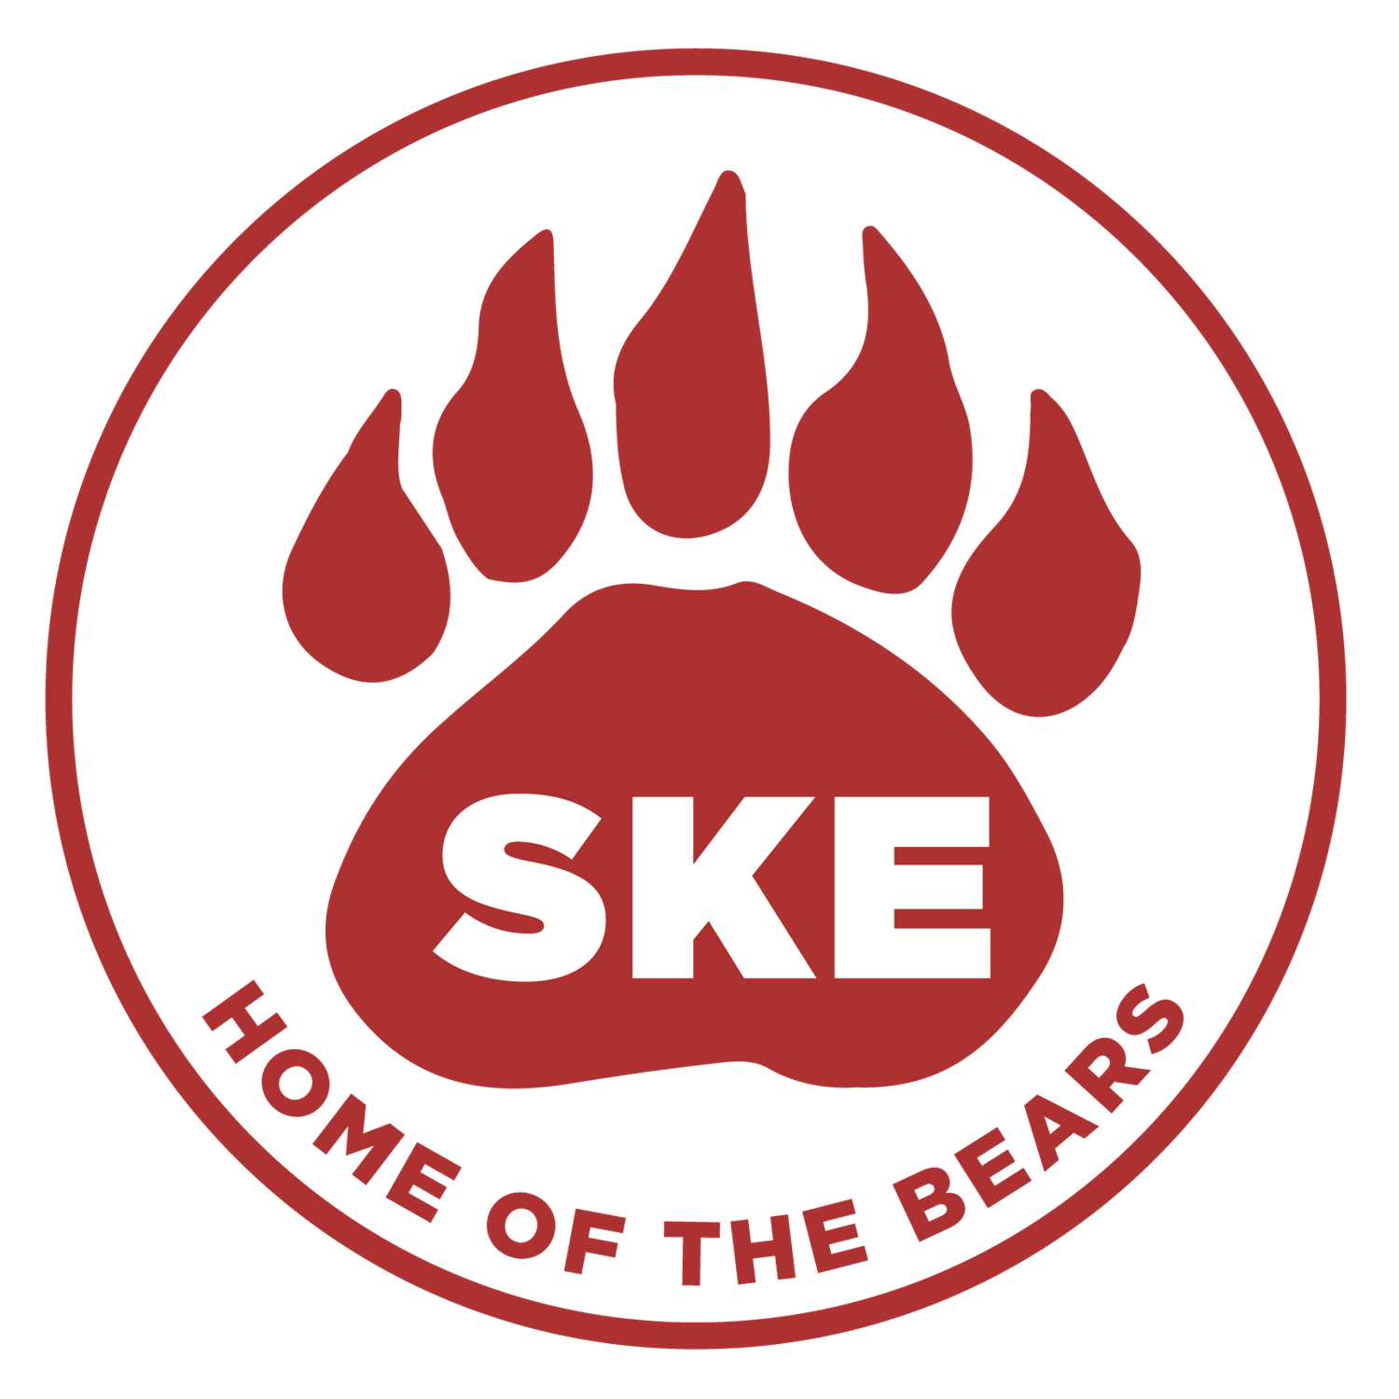  - 2021-2022  Annual Title I Meeting  August 26, 2021  3:15 – 4:00 in the Library  Please join us for our annual Title I meeting. Families will learn about:  our school’s Title I program and how families can be involved;  - the school improvement plan;  - our parent and family engagement policy;  - curriculum;  - assessments;  - how you can help your child be successful this year; and  - much more!  We look forward to seeing you there! | Please join us for this important meeting!  ____  Sign-in Begins at 3:00  ____  Please tour the school for Open House from 4:00 – 6:00 following the meeting.  For more information, please contact:  Craig Casteel or Dr. Tanna Nicely  South Knoxville Elementary  801 Sevier Ave  Knoxville, TN 37920  865-579-2100  https://www.knoxschools.org/southknoxvillees  Dr. Tanna Nicely, Principal

