Central High School
A.P. Language and Composition
Mrs. Andrea Turner
Summer Reading List 2019

Welcome to AP Language and Composition! This AP course emphasizes a mix of politics, history, social sciences, current events and non­fiction prose.

You are expected to complete the following assignments and submit written work on the first FULL day of school, Tuesday, August 6.

Help​: If you have questions, please e-mail me (andrea.turner@knoxschools.org). Do not wait until the first day of class!

Due Date​: These assignments are due the first FULL day of school, August 6. There is no excuse for an AP student to begin the course without the work. No excuses are acceptable; you are responsible for completing your work. Please do not say, "I did not get the assignment," "I did not know my schedule" etc. Failure to complete the assignment will result in zero’s for the semester’s first assignments. I will immediately contact your parents/guardians if the assignment is missing.

By completing these summer reading and language activities, you will prepare for success in this class. I hope you will also enjoy the reading and that it provides you with the opportunity to see the world from a different perspective, as well as appreciate the universality of human experience conveyed by literature.

Summer reading summary - 3 books, 3 written assignments
(please read through in depth explanations for further clarification):
- Read The Radium Girls by Kate Moore and complete a DEJ (double-entry journal) in which you analyze the author’s use of rhetorical devices throughout the book.
- Read I am Malala by Malala Yousafzai and compose an informal reflection about Malala’s purpose for writing the book - roughly 5 paragraphs (ex: one for each section of the book).
- Read ONE of the four choice novels (The Unthinkable, In Cold Blood, The Girls of Atomic City, or The Immortal Life of Henrietta Lacks) and choose ONE of the three writing options to complete about the book you chose to read.
PART ONE: Nonfiction Literature
In this introductory assignment for AP English Language and Composition, you will focus on critical analysis ​of the texts you are reading. This will require you to read closely and carefully – in “study mode”. Yes, you need to read for literal meaning (to understand what is going on in the text), but you will also need to read critically.​To analyze ​is to break up a complicated text into its component parts, examine those parts individually, and explain how they work together to fulfill the author’s intended purpose.

**​The specific rhetorical element that I would like you to focus on while you read is TONE. TONE ​is defined as the author’s attitude toward the subject or theme, revealed through stylistic choices. There are many stylistic choices an author might use. These writing choices include (but are not limited to) DICTION, SYNTAX, and FIGURATIVE LANGUAGE.

DICTION ​— word choice, to convey tone, purpose, or effect.
For example, a sentence like “Johnny walked to the park” is pretty straightforward and has a neutral tone. However, if I want to convey the idea that walking to the park is drudgery for Johnny, I can play with the verb “walked” and change it to this: “Johnny trudged to the park.” Other “walk” verbs that convey emotion include “pranced”, “slithered”, “glided”, “marched”, “skipped”, “slogged”, “ambled”, “sashayed”, and “strutted”. Think of how the changing of one word changes the whole feel of the sentence. It all depends on what the author wants to convey.

SYNTAX​—how words are arranged into sentences to convey meaning; sentence structure. Authors may play with the order and arrangement of words to create a particular effect.
For example, short, choppy sentences can create a sense of urgency if that is the author’s intention: “Quick! Get help! Someone’s hurt. A broken leg. Hurry!” A balanced sentence structure might be saved for a memorable message: “Ask not what your country can do for you ­ ask what you can do for your country” The dash represents the linguistic fulcrum that Kennedy’s famous challenge balances on – the reversal of terms also makes it memorable (fancy term for this “flip”: chiasmus) A periodic sentence, in which the main clause is saved until the end, may be used to create a sense of tension or expectation. Patrick Henry was an expert: "If we wish to be free, if we mean to preserve inviolate those inestimable privileges for which we have been so long contending, if we mean not basely to abandon the noble struggle in which we have been so long engaged, and which we have pledged ourselves never to abandon until the glorious object of our contest shall be obtained, ​we must fight​!”
There you have it – Henry keeps throwing all these “if we” conditionals at us, until the building up of conditions demands an action: “we must fight” breaks the tension and satisfies the conditions.

FIGURATIVE LANGUAGE – ​(in contrast to LITERAL language) has levels of meaning expressed through figures of speech such as personification, metaphor, hyperbole, irony, metonymy, etc.
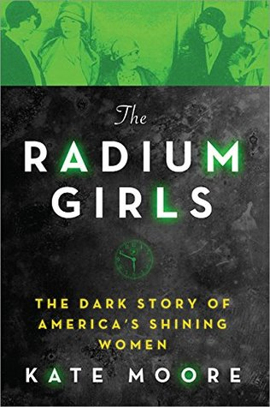
For example, this is how Zora Neale Hurston uses figurative language when Janie Starks goes to her husband’s funeral in Their Eyes Were Watching God: “Janie starched and ironed her face and came set in the funeral behind her veil. It was like a wall of stone and steel. The funeral was going on outside . . . She sent her face to the funeral, and herself went rollicking with the springtime across the world.” The images here show a barrier between Janie’s outward form and appearance of solemnity for the dead, but within she is actually celebrating. The figurative language expresses this separation in a fresh and interesting way.

YOUR ASSIGNMENTS (2 TEXTS):
- Read The Radium Girls: The Dark Story of America's Shining Women, Kate Moore: In the dark years of the first World War, hundreds of girls toil amidst the glowing dust of the radium-dial factories. The glittering chemical covers their bodies from head to toe; they light up the night like industrious fireflies. With such a coveted job, these "shining girls" are the luckiest alive — until they begin to fall mysteriously ill. But the factories that once offered golden opportunities are now ignoring all claims of the gruesome side effects, and the women's cries of corruption. And as the fatal poison of the radium takes hold, the brave shining girls find themselves embroiled in one of the biggest scandals of America's early 20th century, and in a groundbreaking battle for workers' rights that will echo for centuries to come...
  - While reading, complete at least four Double ­Entry Journals(DEJ). Aim for one entry per section of the book. Your entries should be a fair balance of the three rhetorical stylistic choices above,­ noting how your chosen textual excerpt has a particular rhetorical feature that contributes to tone. You may want to include (as extra) entries that address questions you have, clarifications of things in the text, especially memorable quotes, etc. **the sample DEJ on the last page was completed for In Cold Blood but provides a model of format and content**
  - Your The Radium Girls DEJ is due the first full day of school and should be shared with me on google drive (andrea.turner@knoxschools.org). It will be graded for completion as well as for thorough and thoughtful analysis of rhetorical elements at work.
  - Upon our return to school, you will be writing a rhetorical analysis essay of The Radium Girls in class, using your DEJs to support your analysis. Thus, the better your journal entries are, the easier your essay will be to write.
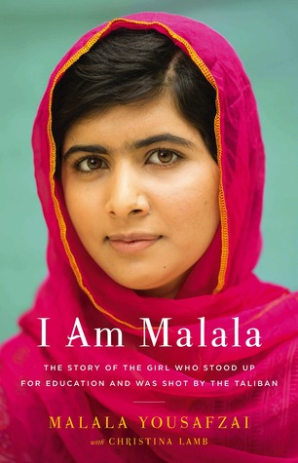
- Read I am Malala, Malala Yousifzai. DO NOT BUY THE “YOUNG READERS EDITION”! Malala Yousafzai was only ten years old when the Taliban took control of her region. They said music was a crime. They said women weren't allowed to go to the market. They said girls couldn't go to school. Raised in a once-peaceful area of Pakistan transformed by terrorism, Malala was taught to stand up for what she believes. So she fought for her right to be educated. And on October 9, 2012, she nearly lost her life for the cause: She was shot point-blank while riding the bus on her way home from school. No one expected her to survive.
  - While reading, complete an informal written reflection regarding Malala’s purpose in writing the book. The reflection should be approximately 5 paragraphs (one for each section of the book). Discuss her purpose as it builds and develops across the book. Consider the rhetorical elements of TONE as listed above. How do they support her overall purpose?
  - Your Malala written reflection is due the first full day of school and should be shared with me on google drive (andrea.turner@knoxschools.org). It will be graded for completion as well as for thoughtful analysis of author purpose.
  - Upon our return to school, you will be writing an argumentative essay about Malala. Thus, the better your reflection is, the easier your essay will be to write.

PART TWO:​­ Nonfiction American Literature/History
For this part, you will choose and read ONE of the following nonfiction novels, then write a response:
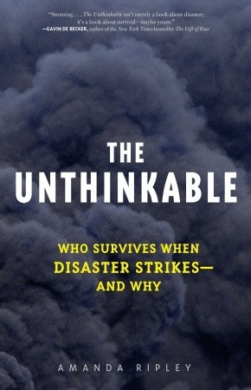
- The Unthinkable, Amanda Ripley: Today, nine out of ten Americans live in places at significant risk of earthquakes, hurricanes, tornadoes, terrorism, or other disasters. Tomorrow, some of us will have to make split-second choices to save ourselves and our families. How will we react? What will it feel like? Will we be heroes or victims? Will our upbringing, our gender, our personality –anything we’ve ever learned, thought, or dreamed of–ultimately matter?...This book escorts us into the bleakest regions of our nightmares, flicks on a flashlight, and takes a steady look around. Then it leads us home, smarter and stronger than we were before.

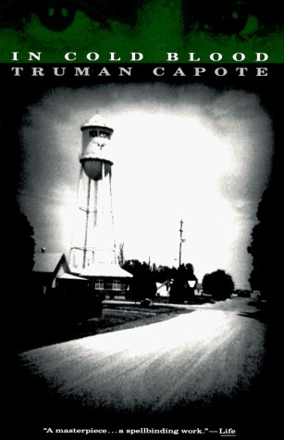
- In Cold Blood, Truman Capote. On November 15, 1959, in the small town of Holcomb, Kansas, four members of the Clutter family were savagely murdered by blasts from a shotgun held a few inches from their faces. There was no apparent motive for the crime, and there were almost no clues.

As Truman Capote reconstructs the murder and the investigation that led to the capture, trial, and execution of the killers, he generates both mesmerizing suspense and astonishing empathy. In Cold Blood is a work that transcends its moment, yielding poignant insights into the nature of American violence.

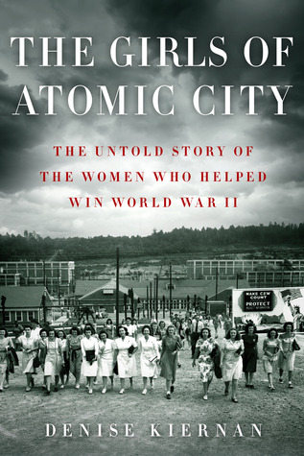
- The Girls of Atomic City, Denise Kiernan: The Tennessee town of Oak Ridge was created from scratch in 1942. One of the Manhattan Project’s secret cities, it didn’t appear on any maps until 1949, and yet at the height of World War II it was using more electricity than New York City and was home to more than 75,000 people, many of them young women recruited from small towns across the South. Their jobs were shrouded in mystery...against this vibrant wartime backdrop, a darker story was unfolding... Kiernan traces the astonishing story of these unsung WWII workers through interviews with dozens of surviving women and other Oak Ridge residents. This is history and science made fresh and vibrant—a beautifully told, deeply researched story that unfolds in a suspenseful and exciting way.

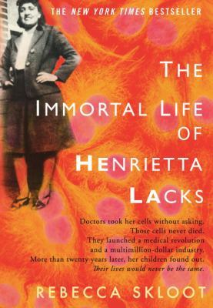
- The Immortal Life of Henrietta Lacks, Rebecca Skloot: Her name was Henrietta Lacks, but scientists know her as HeLa. She was a poor Southern tobacco farmer who worked the same land as her slave ancestors, yet her cells—taken without her knowledge—became one of the most important tools in medicine. The first “immortal” human cells grown in culture, they are still alive today, though she has been dead for more than sixty years. If you could pile all HeLa cells ever grown onto a scale, they’d weigh more than 50 million metric tons—as much as a hundred Empire State Buildings. HeLa cells were vital for developing the polio vaccine; uncovered secrets of cancer, viruses, and the atom bomb’s effects; helped lead to important advances like in vitro fertilization, cloning, and gene mapping; and have been bought and sold by the billions. Yet Henrietta Lacks remains virtually unknown, buried in an unmarked grave.

YOUR ASSIGNMENTS (CHOICE TEXT):
- Writing Option A: Identify the central argument of the book, then agree with the claim, argue against the claim, or qualify the claim by saying when it is accurate and when it is inaccurate. Provide evidence from history, literature, current events, or personal experience. No outside sources are required beyond the book you read, and any time you deal with a source, cite it according to MLA guidelines.
- Writing Option B: Persuasive writing can appeal to emotion, logic, or morals and values. Appeals to morals and values are called ethos; appeals to emotion are called pathos; appeals to logic and reason are called logos. Discuss the balance or imbalance of logos, pathos, and ethos in the book you read, citing specific bits of the book as evidence. No outside sources are required, but you will need to cite the book according to MLA guidelines.
- Writing Option C: This is the open option. Make any/prove any opinion about any aspect of the book you read. No outside sources are required, but if you use outside sources, cite them according to MLA guidelines.
